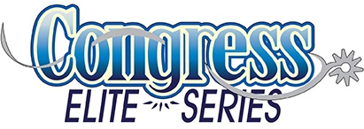
Wednesday, August 2 – Sunday, August 6, 2017
Built Ford Tough Livestock Complex – Tulsa, Oklahoma
CONGRESS ELITE SERIES SPONSORS
Western Pleasure & Hunter Under Saddle
As of 7/23/2017
THANK YOU

Elite Custom Saddles
Jeff Fischer
Cowboy Couture
Conklin Auction Services
B-Free of Flies
BackRoad Trading Company
Barbara’s Custom Hats
Bobbitt Pleasure Horses
Boehringer Ingelheim Animal Health/
Legend & Ulcer Guard
Boo Yah Custom Clothing
Brinks Hattery
Candi’s Custom Creations
Carson James
Elite Show Horses
Equine Aqua Spa Center
Equine Auction Exchange
Espuela Ranch
Eurosian Auto
Kathy’s Show Equipment
Greg, Heidi, Taylor Kokemiller
Nutra Ag
Perri’s Leather
Premier Equine Products
Ric’s Leather & Engraving
Megan & Sabrina Seehafer
Show Off Designs
Sorta Sleazy Horsewear
Sterling Saddles
Sunburst Saddle Blankets
The Sugar Daddy
The Unbridled Boutique
TS Paints
Valley Vet Supply
Wasson Performance Horses

